Practice Does Not Make Perfect
We are not all created equal where our genes and abilities are concerned.

By David Z. Hambrick, Fernanda Ferreira, and John M. Henderson
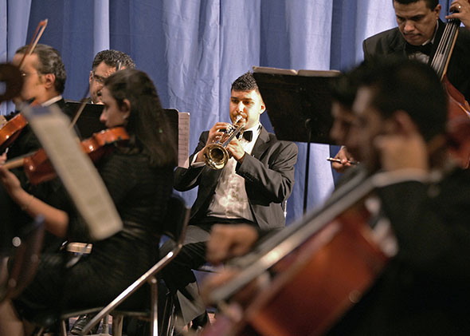
Members of Iraq's National Symphony Orchestra perform at the National Theatre in Baghdad on Oct. 28, 2011. Not everyone needs 10,000 hours of practice to be great at something.
A decade ago, Magnus Carlsen, who at the time was only 13 years old, created a sensation in the chess world when he defeated former world champion Anatoly Karpov at a chess tournament in Reykjavik, Iceland, and the next day played then-top-rated Garry Kasparov—who is widely regarded as the best chess player of all time—to a draw. Carlsen’s subsequent rise to chess stardom was meteoric: grandmaster status later in 2004; a share of first place in the Norwegian Chess Championship in 2006; youngest player ever to reach World No. 1 in 2010; and highest-rated player in history in 2012.

What explains this sort of spectacular success? What makes someone rise to the top in music, games, sports, business, or science? This question is the subject of one of psychology’s oldest debates. In the late 1800s, Francis Galton—founder of the scientific study of intelligence and a cousin of Charles Darwin—analyzed the genealogical records of hundreds of scholars, artists, musicians, and other professionals and found that greatness tends to run in families. For example, he counted more than 20 eminent musicians in the Bach family. (Johann Sebastian was just the most famous.) Galton concluded that experts are “born.” Nearly half a century later, the behaviorist John Watson countered that experts are “made” when he famously guaranteed that he could take any infant at random and “train him to become any type of specialist [he] might select—doctor, lawyer, artist, merchant-chief and, yes, even beggar-man and thief, regardless of his talents.”
One player needed 22 times more deliberate practice than another player to become a master.

The experts-are-made view has dominated the discussion in recent decades. In a pivotal 1993 article published in Psychological Review—psychology’s most prestigious journal—the Swedish psychologist K. Anders Ericsson and his colleagues proposed that performance differences across people in domains such as music and chess largely reflect differences in the amount of time people have spent engaging in “deliberate practice,” or training exercises specifically designed to improve performance. To test this idea, Ericsson and colleagues recruited violinists from an elite Berlin music academy and asked them to estimate the amount of time per week they had devoted to deliberate practice for each year of their musical careers. The major finding of the study was that the most accomplished musicians had accumulated the most hours of deliberate practice. For example, the average for elite violinists was about 10,000 hours, compared with only about 5,000 hours for the least accomplished group. In a second study, the difference for pianists was even greater—an average of more than 10,000 hours for experts compared with only about 2,000 hours for amateurs. Based on these findings, Ericsson and colleagues argued that prolonged effort, not innate talent, explained differences between experts and novices.
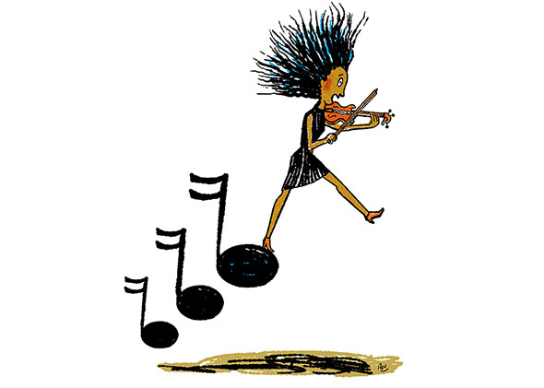
Illustration by Robert Neubecker.

These findings filtered their way into pop culture. They were the inspiration for what Malcolm Gladwell termed the “10,000 Hour Rule” in his book Outliers, which in turn was the inspiration for the song “Ten Thousand Hours” by the hip-hop duo Macklemore and Ryan Lewis, the opening track on their Grammy-award winning album The Heist. However, recent research has demonstrated that deliberate practice, while undeniably important, is only one piece of the expertise puzzle—and not necessarily the biggest piece. In the first study to convincingly make this point, the cognitive psychologists Fernand Gobet and Guillermo Campitelli found that chess players differed greatly in the amount of deliberate practice they needed to reach a given skill level in chess. For example, the number of hours of deliberate practice to first reach “master” status (a very high level of skill) ranged from 728 hours to 16,120 hours. This means that one player needed 22 times more deliberate practice than another player to become a master.

A recent meta-analysis by Case Western Reserve University psychologist Brooke Macnamara and her colleagues (including the first author of this article for Slate) came to the same conclusion. We searched through more than 9,000 potentially relevant publications and ultimately identified 88 studies that collected measures of activities interpretable as deliberate practice and reported their relationships to corresponding measures of skill. (Analyzing a set of studies can reveal an average correlation between two variables that is statistically more precise than the result of any individual study.) With very few exceptions, deliberate practice correlated positively with skill. In other words, people who reported practicing a lot tended to perform better than those who reported practicing less. But the correlations were far from perfect: Deliberate practice left more of the variation in skill unexplained than it explained. For example, deliberate practice explained 26 percent of the variation for games such as chess, 21 percent for music, and 18 percent for sports. So, deliberate practice did not explain all, nearly all, or even most of the performance variation in these fields. In concrete terms, what this evidence means is that racking up a lot of deliberate practice is no guarantee that you’ll become an expert. Other factors matter.
If one identical twin was good at drawing, it was quite likely that his or her identical sibling was, too.
What are these other factors? There are undoubtedly many. One may be the age at which a person starts an activity. In their study, Gobet and Campitelli found that chess players who started playing early reached higher levels of skill as adults than players who started later, even after taking into account the fact that the early starters had accumulated more deliberate practice than the later starters. There may be a critical window during childhood for acquiring certain complex skills, just as there seems to be for language.
There is now compelling evidence that genes matter for success, too. In a study led by the King’s College London psychologist Robert Plomin, more than 15,000 twins in the United Kingdom were identified through birth records and recruited to perform a battery of tests and questionnaires, including a test of drawing ability in which the children were asked to sketch a person. In a recently published analysis of the data, researchers found that there was a stronger correspondence in drawing ability for the identical twins than for the fraternal twins. In other words, if one identical twin was good at drawing, it was quite likely that his or her identical sibling was, too. Because identical twins share 100 percent of their genes, whereas fraternal twins share only 50 percent on average, this finding indicates that differences across people in basic artistic ability are in part due to genes. In a separate study based on this U.K. sample, well over half of the variation between expert and less skilled readers was found to be due to genes.

In another study, a team of researchers at the Karolinska Institute in Sweden led by psychologist Miriam Mosing had more than 10,000 twins estimate the amount of time they had devoted to music practice and complete tests of basic music abilities, such as determining whether two melodies carry the same rhythm. The surprising discovery of this study was that although the music abilities were influenced by genes—to the tune of about 38 percent, on average—there was no evidence they were influenced by practice. For a pair of identical twins, the twin who practiced music more did not do better on the tests than the twin who practiced less. This finding does not imply that there is no point in practicing if you want to become a musician. The sort of abilities captured by the tests used in this study aren’t the only things necessary for playing music at a high level; things such as being able to read music, finger a keyboard, and commit music to memory also matter, and they require practice. But it does imply that there are limits on the transformative power of practice. As Mosing and her colleagues concluded, practice does not make perfect.

Along the same lines, biologist Michael Lombardo and psychologist Robert Deaner examined the biographies of male and female Olympic sprinters such as Jesse Owens, Marion Jones, and Usain Bolt, and found that, in all cases, they were exceptional compared with their competitors from the very start of their sprinting careers—before they had accumulated much more practice than their peers.

What all of this evidence indicates is that we are not created equal where our abilities are concerned. This conclusion might make you uncomfortable, and understandably so. Throughout history, so much wrong has been done in the name of false beliefs about genetic inequality between different groups of people—males vs. females, blacks vs. whites, and so on. War, slavery, and genocide are the most horrifying examples of the dangers of such beliefs, and there are countless others. In the United States, women were denied the right to vote until 1920 because too many people believed that women were constitutionally incapable of good judgment; in some countries, such as Saudi Arabia, they still are believed to be. Ever since John Locke laid the groundwork for the Enlightenment by proposing that we are born as tabula rasa—blank slates—the idea that we are created equal has been the central tenet of the “modern” worldview. Enshrined as it is in the Declaration of Independence as a “self-evident truth,” this idea has special significance for Americans. Indeed, it is the cornerstone of the American dream—the belief that anyone can become anything they want with enough determination.

It is therefore crucial to differentiate between the influence of genes on differences in abilities across individuals and the influence of genes on differences across groups. The former has been established beyond any reasonable doubt by decades of research in a number of fields, including psychology, biology, and behavioral genetics. There is now an overwhelming scientific consensus that genes contribute to individual differences in abilities. The latter has never been established, and any claim to the contrary is simply false.
Pretending we have the same abilities perpetuates the myth that people can help themselves if they just try hard enough.

Another reason the idea of genetic inequality might make you uncomfortable is because it raises the specter of an anti-meritocratic society in which benefits such as good educations and high-paying jobs go to people who happen to be born with “good” genes. As the technology of genotyping progresses, it is not far-fetched to think that we will all one day have information about our genetic makeup, and that others—physicians, law enforcement, even employers or insurance companies—may have access to this information and use it to make decisions that profoundly affect our lives. However, this concern conflates scientific evidence with how that evidence might be used—which is to say that information about genetic diversity can just as easily be used for good as for ill.

Take the example of intelligence, as measured by IQ. We know from many decades of research in behavioral genetics that about half of the variation across people in IQ is due to genes. Among many other outcomes, IQ predicts success in school, and so once we have identified specific genes that account for individual differences in IQ, this information could be used to identify, at birth, children with the greatest genetic potential for academic success and channel them into the best schools. This would probably create a society even more unequal than the one we have. But this information could just as easily be used to identify children with the least genetic potential for academic success and channel them into the best schools. This would probably create a more equal society than the one we have, and it would do so by identifying those who are likely to face learning challenges and provide them with the support they might need. Science and policy are two different things, and when we dismiss the former because we assume it will influence the latter in a particular and pernicious way, we limit the good that can be done.

Wouldn’t it be better to just act as if we are equal, evidence to the contrary notwithstanding? That way, no people will be discouraged from chasing their dreams—competing in the Olympics or performing at Carnegie Hall or winning a Nobel Prize. The answer is no, for two reasons. The first is that failure is costly, both to society and to individuals. Pretending that all people are equal in their abilities will not change the fact that a person with an average IQ is unlikely to become a theoretical physicist, or the fact that a person with a low level of music ability is unlikely to become a concert pianist. It makes more sense to pay attention to people’s abilities and their likelihood of achieving certain goals, so people can make good decisions about the goals they want to spend their time, money, and energy pursuing. Moreover, genes influence not only our abilities, but the environments we create for ourselves and the activities we prefer—a phenomenon known as gene-environment correlation. For example, yet another recent twin study (and the Karolinska Institute study) found that there was a genetic influence on practicing music. Pushing someone into a career for which he or she is genetically unsuited will likely not work.

The second reason we should not pretend we are endowed with the same abilities is that doing so perpetuates the myth that is at the root of much inaction in society—the myth that people can help themselves to the same degree if they just try hard enough. You’re not a heart surgeon? That’s your fault for not working hard enough in school! You didn’t make it as a concert pianist? You must not have wanted it that badly. Societal inequality is thus justified on the grounds that anyone who is willing to put in the requisite time and effort can succeed and should be rewarded with a good life, whereas those who struggle to make ends meet are to blame for their situations and should pull themselves up by their own bootstraps. If we acknowledge that people differ in what they have to contribute, then we have an argument for a society in which all human beings are entitled to a life that includes access to decent housing, health care, and education, simply because they are human. Our abilities might not be identical, and our needs surely differ, but our basic human rights are universal.

<http://www.slate.com/articles/health_and_science/science/2014/09/malcolm_gladwell_s_10_000_hour_rule_for_deliberate_practice_is_wrong_genes.html>

